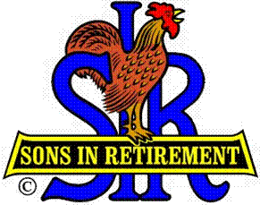
Las Trampas Branch 116
Luncheon Meeting Agenda
April 15, 2024, 11:30 AM

10:30 Social Hour
Greeters – Paul Ramaciotti, _________________
New Member Orientation – Tom Eller
11:25 Five Minute Call
11:30 Call to order – Big SIR
Pledge of Allegiance –
Invocation– Brad Stribling
11:36 Story Teller – Mac Mcloughlin
11:42 Introduce Attendance of Speaker – Ron Baskett

New Members - Noel Concepcion; Sponsor Peter Loew; Kirk Harding; Sponsor: Don Schroeder; Jim Ranger, Sponsor: Tom O’Brien ; Garrett Romain, Sponsor; Steve Beck

Guests – Doug Roaldson; Sponsor: Roger Craig;

11:45 Salad Served
11:46 Activity Reports (Spring Fling included)
12:00 Lunch
12:20 Introduce Speaker – Little SIR
12:22 Speaker Ron Baskett, Consulting Meterorologist
12:52 Speaker Thank You – Big SIR
12:25 Raffle Drawing – Ben Bryce, Bob Huck
Birthday Drawing – Little SIR
12:35 Sing Happy Birthday
Sing God Bless America
12:28 Closing Remarks – Big SIR
13:30 Adjourn; Next Meeting, June 17, 2024

